CLOUD BASED TEMPERATURE AND HUMIDITY MONITORING

Rohan Rana (2013464)

Saksham Chaudhary (2013474)

**GRAPHIC ERA DEEMED TO BE UNIVERSITY**

WHAT IS ARDUINO?

Arduino is an open-source electronics platform based on easy-to-use hardware and software. Arduino boards are able to read inputs - light on a sensor, a finger on a button, or a Twitter message - and turn it into an output - activating a motor, turning on an LED, publishing something online. You can tell your board what to do by sending a set of instructions to the microcontroller on the board. To do so you use the Arduino programming language (based on wiring), and the Arduino software (IDE), based on processing.

Arduino senses the environment by receiving inputs from many sensors, and affects its surroundings by controlling lights, motors, and other actuators.

You can tell your Arduino what to do by writing code in the Arduino programming language and using the Arduino development environment.

## NodeMCU ESP8266:

NodeMCU is an open source development board and firmware based in the widely used ESP8266-12E WiFi module. It allows you to program the ESP8266 WiFi module with the simple and powerful LUA programming language or Arduino IDE.

With just a few lines of code you can establish a WiFi connection and define input/output pins according to your needs exactly like arduino, turning your ESP8266 into a web server and a lot more. It is the WiFi equivalent of Ethernet module. Now you have internet of things (IOT) real tool. ‘

With its USB-TTL, the nodeMCU Dev board supports directly flashing from USB port. It combines features of WIFI access point and station + microcontroller. These features   make the NodeMCU extremely powerful tool for Wifi networking. It can be used as access point and/or station, host a webserver or connect to internet to fetch or upload data.

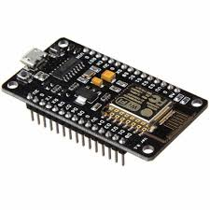

ESP8266 NODEMCU

## DHT 11 sensor:

The DHT11 is a basic, ultra low-cost digital temperature and humidity sensor. It uses a capacitive humidity sensor and a thermistor to measure the surrounding air, and spits out a digital signal on the data pin (no analogue input pins needed). It’s fairly simple to use, but requires careful timing to grab data. The only real downside of this sensor is you can only get new data from it once every 2 seconds, so when using our library, sensor readings can be up to 2 seconds old.

This sensor includes a resistive element and a sensor for wet NTC temperature measuring devices. It has excellent quality, fast response, anti-interference ability and high performance.

|  |  |
| --- | --- |
| Operating Voltage | 3 to 5V |
| Max Operating Current | 2.5mA max |
| Humidity Range | 20-80% / 5% |
| Temperature Range | 0-50°C / ± 2°C |
| Sampling Rate | 1 Hz (reading every second) |

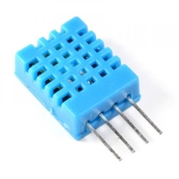

DHT11 sensor